He is shocked by

the wretchedness of humanity

and welcomes the Fire

of the Love of God.

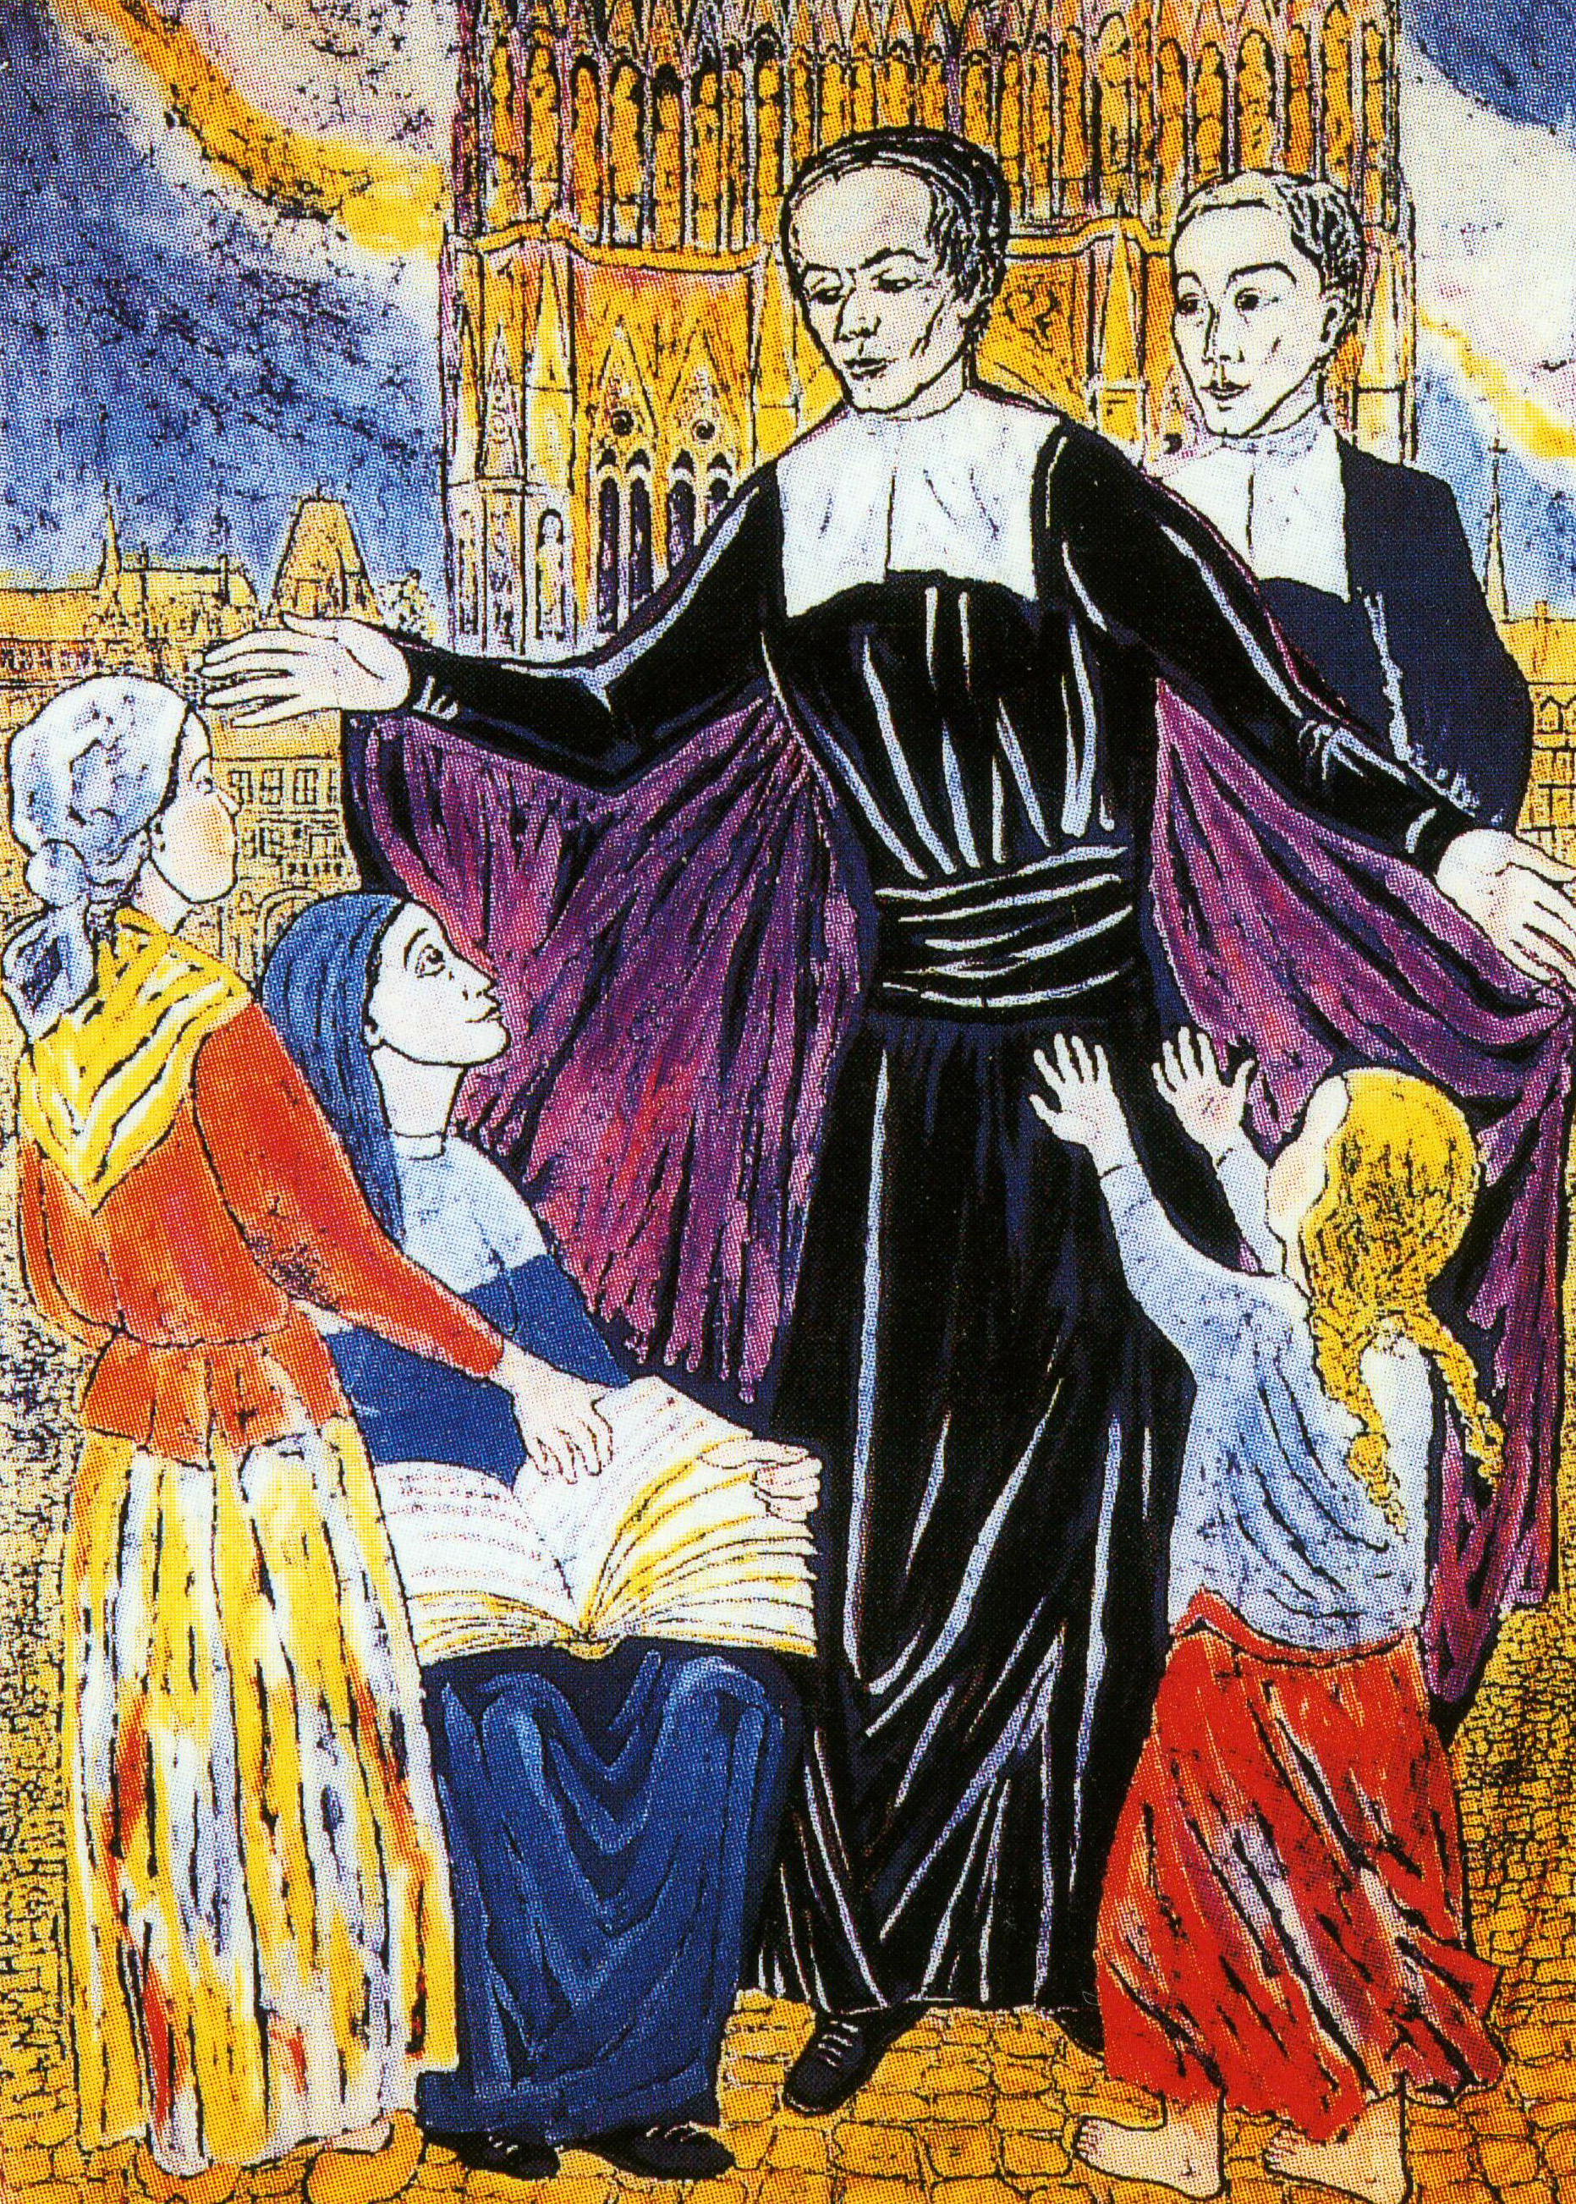

17

Jesus the man with heart ablaze

A man with a heart of flesh,
Who wants to reconcile earth with heaven
Jesus, the Word of life,
A man with a heart of flesh
Invites us to the happiness which his love gives us :
The joy which comes from Him,
comes as a witness of Easter!
Jesus, Word of life, invites us to happiness...

For the glory of God and his highest praise,
For the glory of God,
and the salvation of the world !
Didier Rimaud


I shall follow you Jesus:
Show me the way...

19
Listen

“He who becomes accustomed
to look at God in all his actions
Journeying along the road to God...
Will be the ideal of a blessed soul”.

Nicolas Roland



“If you want to have
a familiar conversation with God,
Try always to walk in his presence.
Be persuaded that God says to you
What he said ages ago to Abraham:
Walk before me and be perfect”.
Nicolas Roland

30

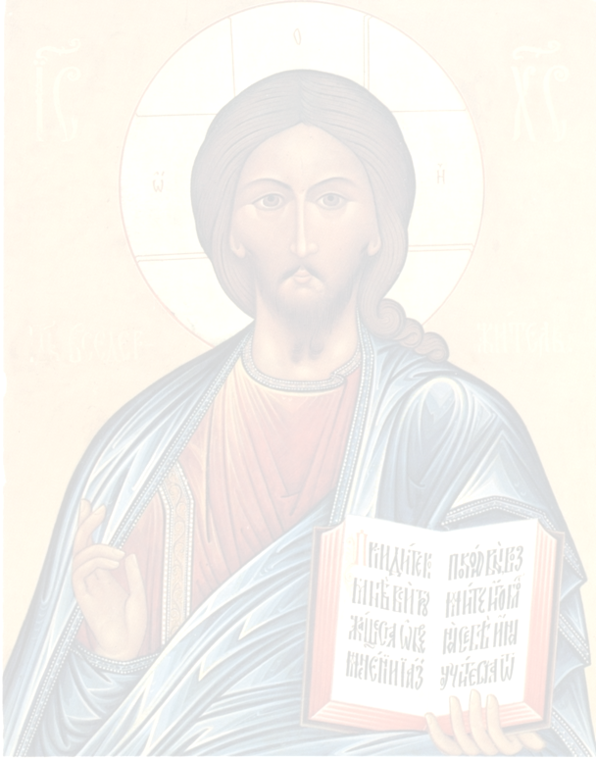
“This is the route : take it”.
Isaïah

“Do not say : I cannot do that.
Because you can do everything
in Him who strengthens you”.
Nicolas Roland


“Bad tools are always good
in the hands of good workmen,
provided they allow themselves to be manipulated and handled
as the workman wishes”.

Nicolas Roland

28

