«Wherever you go
Always have this thought:
God is here, he fills this place.
Who can dare displease God
When he sees Him before him,
Surrounded by all his power,
His wisdom, his pity, his justice ?
Nicolas Roland


“Never condemn things without knowing them,
And when they have several aspects

Look at their most beautiful one”.

Nicolas Roland

31

“I am the vine, you are the branches…
He who remains in me and in whom I live
Will bear much fruit
Because, without me, you can do nothing”.
Jn 15
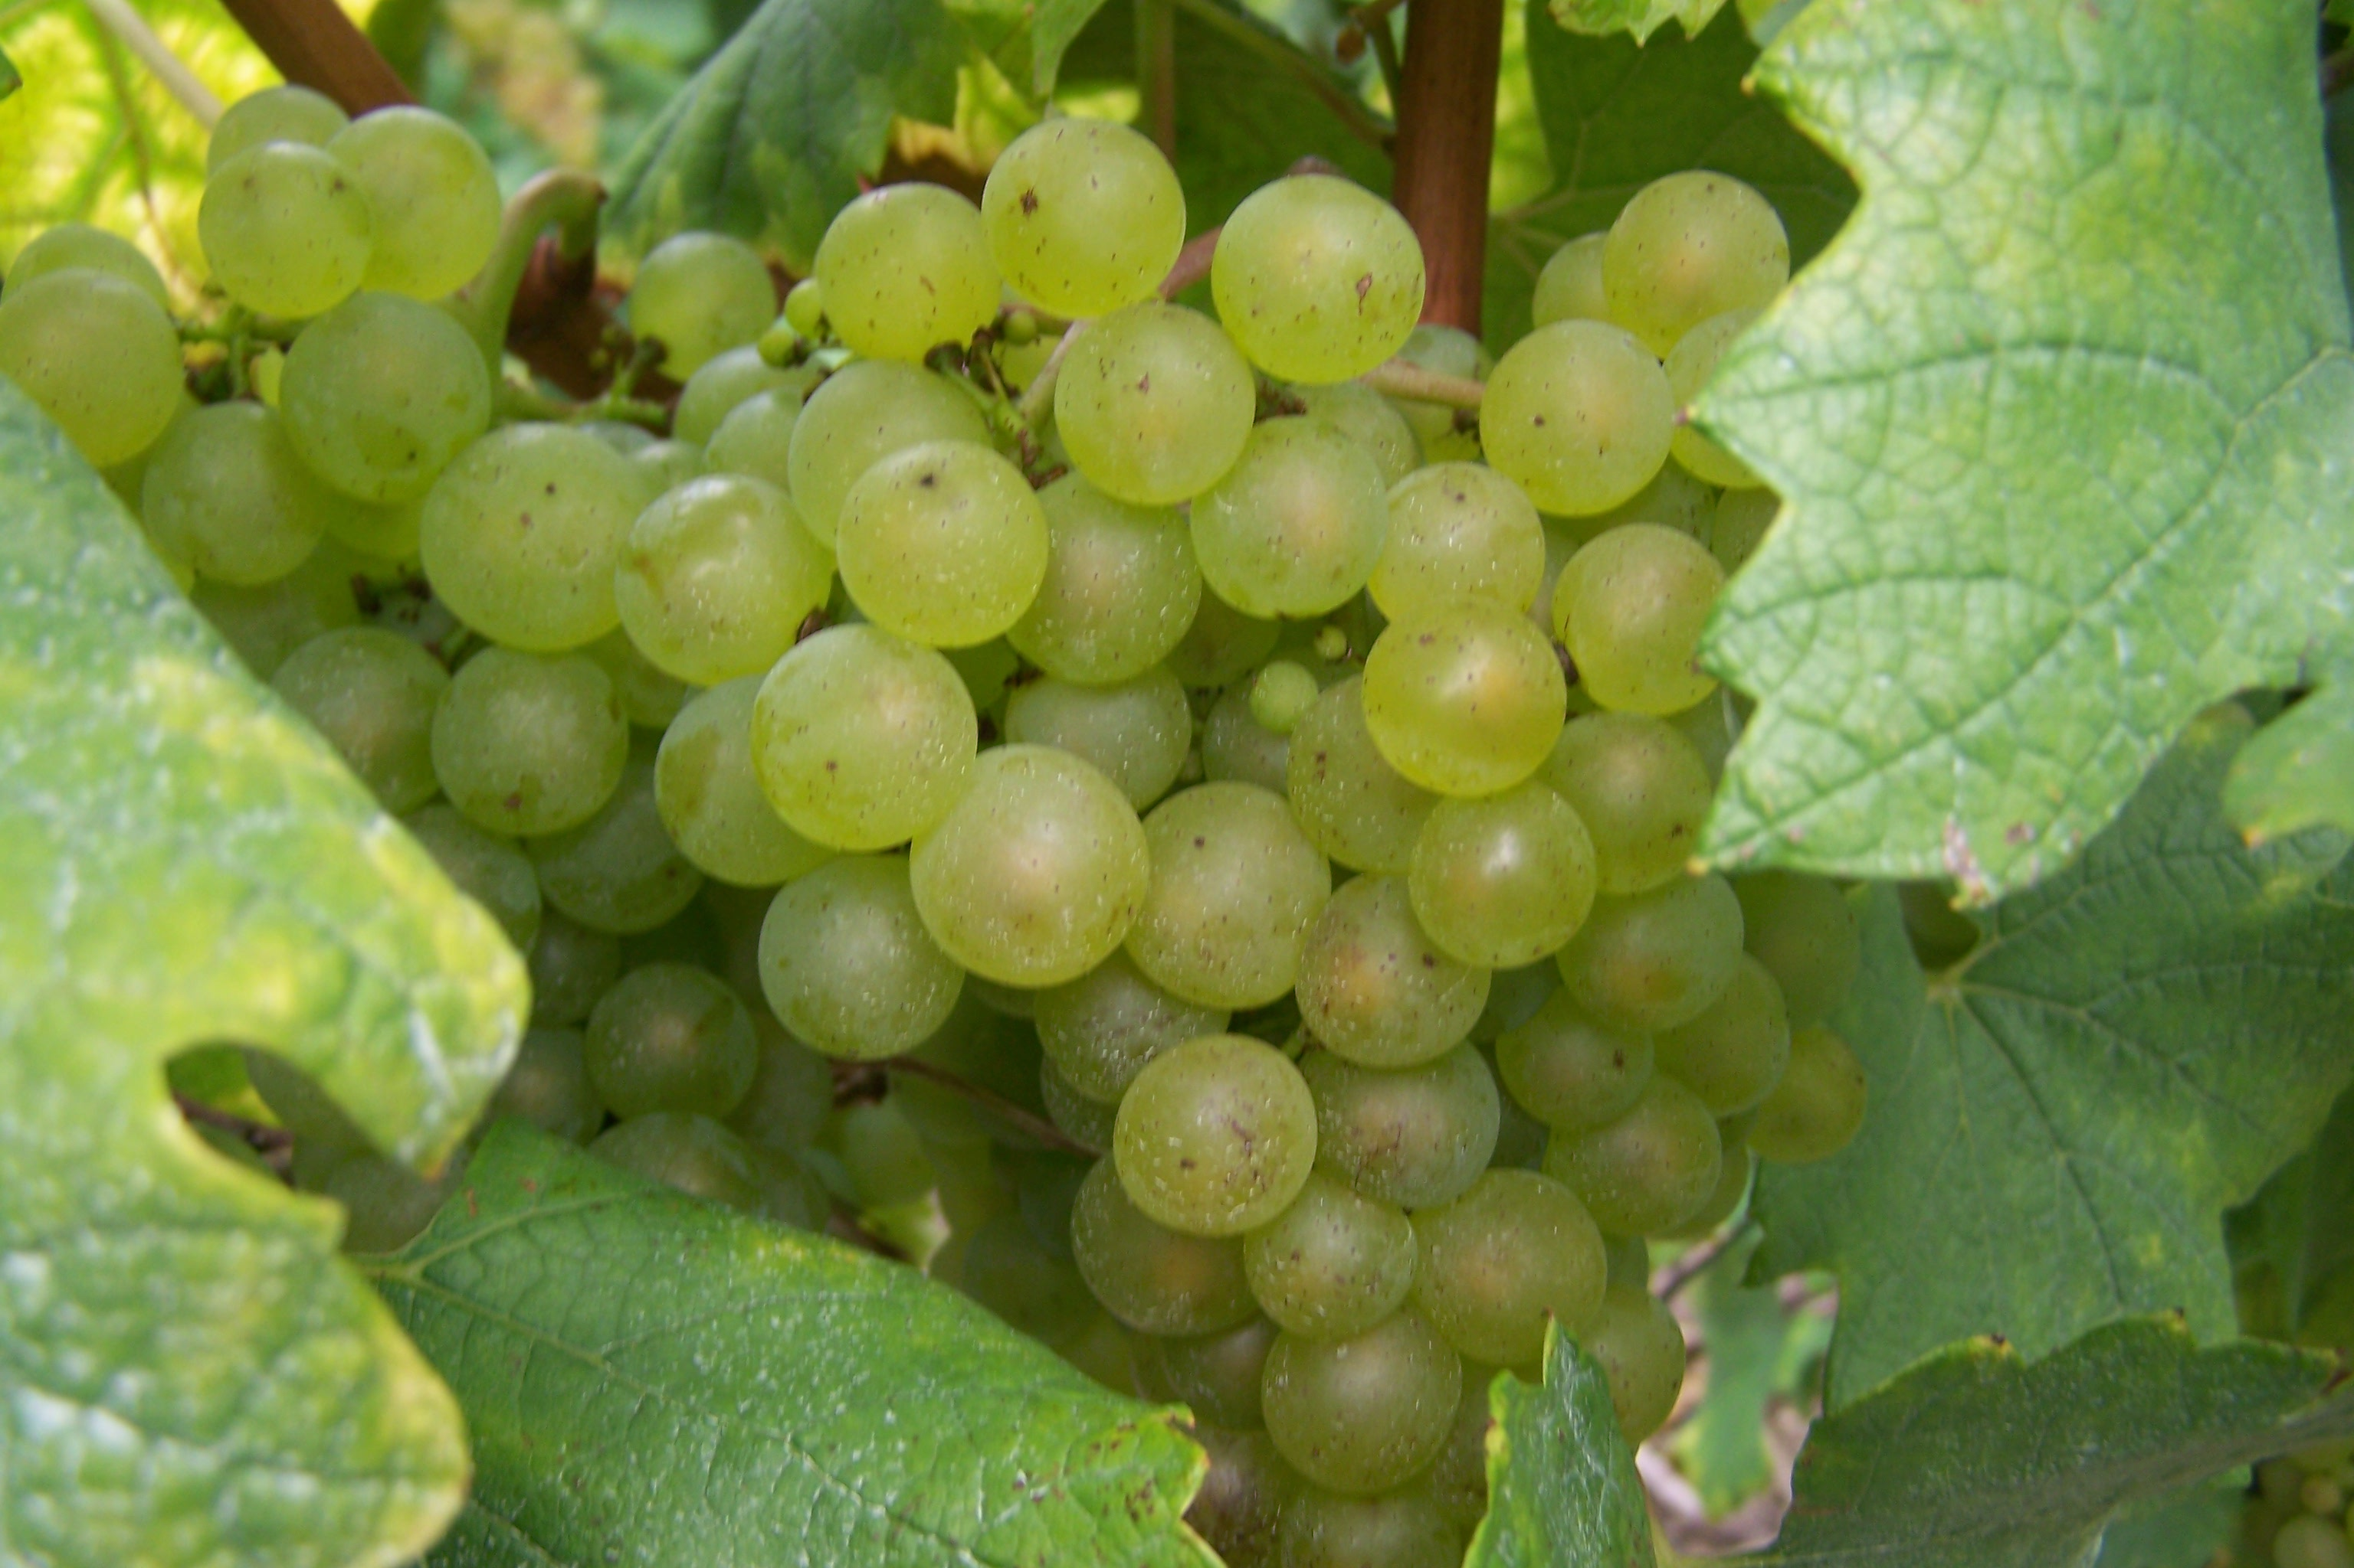

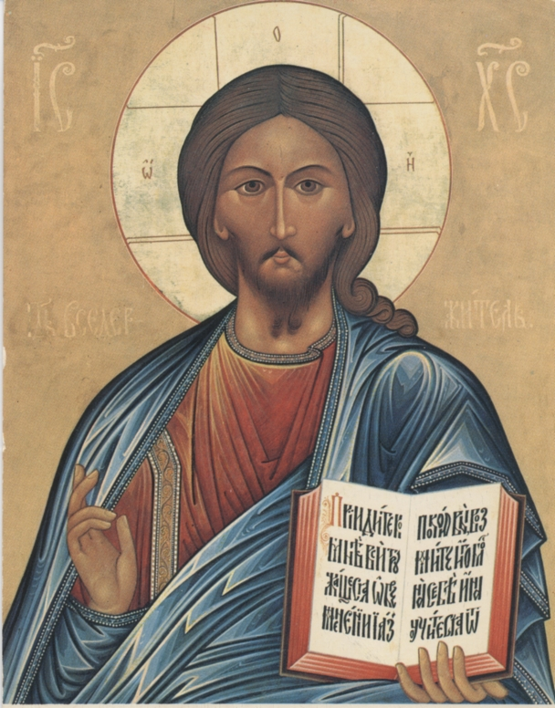
Look at Jesus : adore
(Jesus before your eyes)

Unite yourself with Jesus :
commune with him
(Jesus in our hearts)

Work with Jesus : cooperate
(Jesus in your hands)

An easy way suggested by Olier
( priest of the XVIIe century)
29
Psalm 130

O Lord, my heart is not lifted up
My eyes are not raised too high
I do not worry myself with things
Too great and too marvellous for me.

But my soul is quiet and calm
Like a child at its mother’s breast
Like a child at rest is my soul.
O Israel, hope in the Lord
From this time forth and for evermore.

With Nicolas Roland, overcome by so great a love of the God who became a child, who lowered himself to that extent to be with us :

Divine and adorable Child Jesus
Who so generously
gave yourself to me,
by your holy birth
I look at you, I revere you,
I adore you
in your holy infancy.
O Jesus, the beauty of the heavens,
The delight of angels and the salvation of mankind,
Here I am, humbly prostrated at the foot of your crib,
In order to recognise you all-powerful in your weakness,
Infinitely great in your lowliness.
16

“Love both God and your neighbour with equal charity,
Because God does not separate the charity
That he wants us to have towards Him
from that which he asks us to have
towards of brothers and sisters”.
Nicolas Roland


“Our whole perfection consists in loving God
Love Him with all your strength
Love Him in the place of all who do not love Him”.
Nicolas Roland

18

