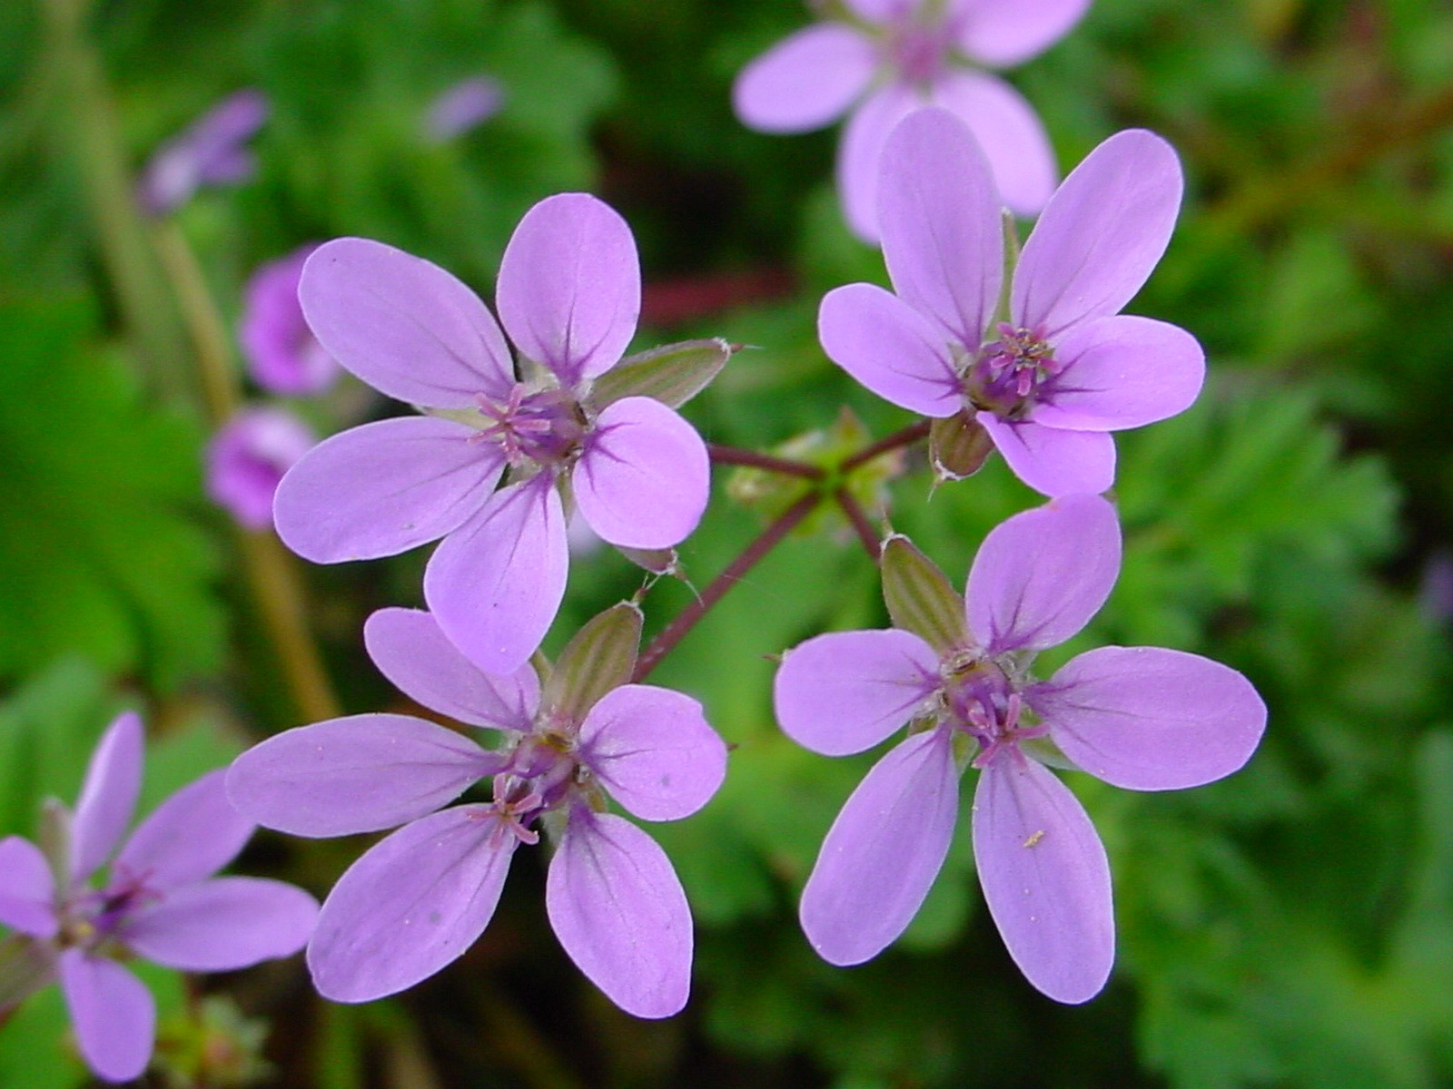

Help us to pray

Jesus, you are always present
In the depth of my soul by your Spirit:
Make me feel that presence.
You are the doctor, cure me.
You are the light, enlighten me.
You are Fire, warm me.
You are the consoler, comfort me.
You are my strength, strengthen me.

Nicolas Roland

35

Blessed Nicolas Roland you said :
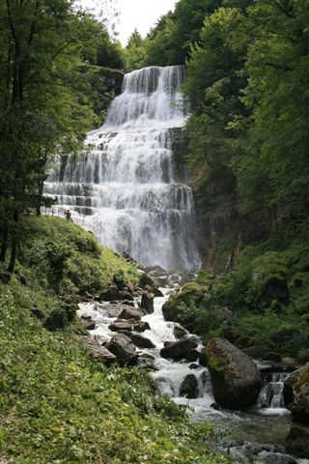

Raise your eyes to Heaven,
To contemplate God there
In all his Beauty, his Greatness.
But also
Look at Him, near you :
He is present in all you do :
Your words, your thoughts,
He is a witness to your every feeling.
Nicolas Roland
33
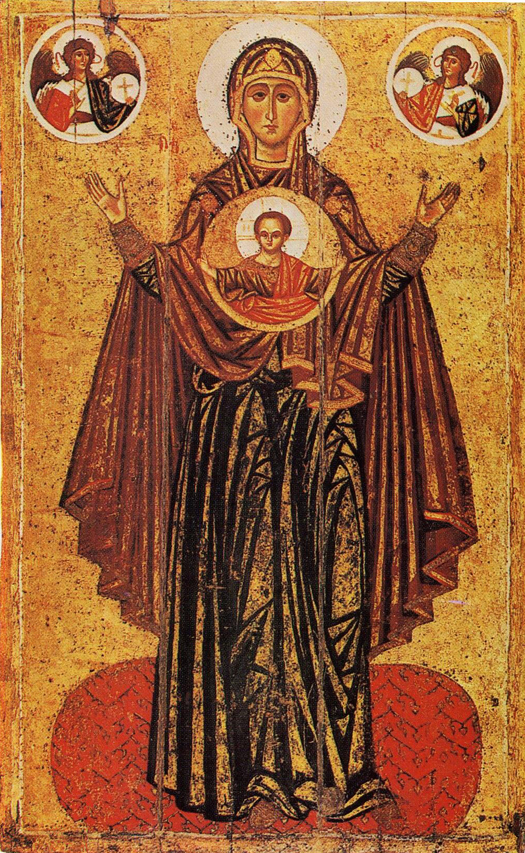
Mary, help me to share
Your attitude of silence,
Of the presence of God, of humility,
So that I can receive in my heart
Jesus, your Divine Son,
And so that the Holy Spirit will form Jesus in me
And in the heart of all those
To whom you send me.
Jesus, be entirely within me.

Dear Jesus, living in Mary,
Come and live in me.
In the tenderness of your heart and your humility,
In your compassion,
in your matchless love come and live in us

Come and live in us, Jesus, Incarnate Word
In your haste to reach the Father,
in your Spirit that you give to us all

Come and live in us, Well-beloved Son of the Father,
Light of light, true God of true God.

Come and live in us, Jesus, Splendour of the Father
Eternal Wisdom, King of Glory.
Dominican Sisters of Langeac
12

When will we allow ourselves
to love through God’s help ?...

Believe in Love, you who would like to perform
great works, but who do not know how to escape
from this world and its snares.
In the heart of God, Nicolas Roland learnt
to love and help this world of ours.
You also, dare to believe
that Someone calls you by your name
Mgr Balland

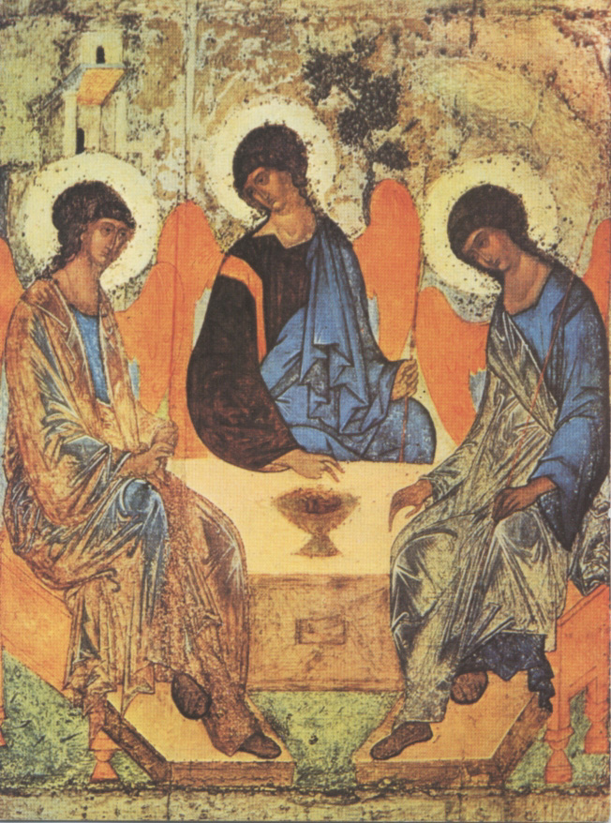
“Ah, when I think
how much God loves us...
I am pierced to the heart to see how the world can pass by without loving
Him who deserves all our love”

Nicolas Roland

14

